http://www.archaeologie-online.de/de/magazin/fundpunkt/forschung/2006/scotts_talisman_damastsalat_und_nanodraht/seite_1/

It's not known, on which of the numerously circulating definitions for the term "damast steel" the research work is based. The data to the "unusual" and "erstaunlichen"[11 ] characteristics of "Damast blade" ("Damascus of blades") remain just as outlineless without reference values as the use of the term "Damascus". The use and definition particularly arbitrary in the German-speaking countries of terms like "damast", "Damaststahl", "Damaszenerstahl", "Damaszierung", etc. for production-determined inhomogenous ferrous metals from different world areas and periods, stands to a necessary differentiation between different methods and development stages of the blade steel preparing in the way. Their avoidance appears therefore necessary under scientific criteria in general and to technology-historical aspects in particular.[12 ] This applies all the more, as in Europe at least since the late Roman epoch by repeated folding and forging highly refined steel was converted to sword blades (s. Abb. 2 A, b).[13]

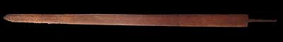
Fig. 2a: A late Roman riding spatha from the 3rd/4.th cent. A.D. Deep corrosion pits at the blade point, point to a special hardening. (photo: Jens Schneider)

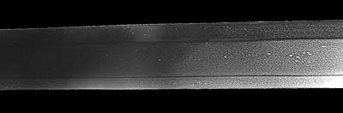
Fig. 2b: Extremely fine fabrication texture on the Japanese polished flat side the same blade. (photo: Jens Schneider) The late Roman to high-medieval sword blade with complex welding samples represent their own extensive group of topics, which cannot be dealt with in the context of this paper (s. Fig. 3).

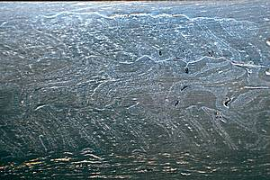
Abb. 3: Welding sample in a "worm-multicolored" spatha blade from the 6th century A.D.. The blade was polished in 1999 in Japan. (photo: Stefan Maeder)

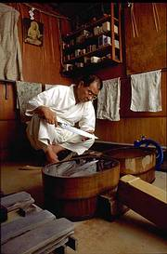
Fig. 4: The sword polisher Takushi Sasaki with a sax blade dating to the 6th century A.D. from Bad Krozingen. (photo: Kenichi Nakajima). Using the same surface treatment, i.e. with application of Japanese polishing methodology, makes visible in the steel of corroded European blade the same developments of an extremely fine processing texture, as well as characteristics of the hardening as with Japanese sword blades (see fig. 4-6, s.u. Anm. 27). To further reveal the complexity of the early steel problem and the range of commercial contacts in former times, as Plinius the elder (approx. 23 to 79 A.D..) stated, where he refers to the Roman import of iron from China:

"ex bus autem generibus palma Serico ferrous est; Seres hoc cum vestibus suis pellibusque mittunt; secunda part CHICO." ("under all sorts however the Palme is entitled to the serischen iron; the Serer sends it together with their garbs and furs; the parthische has second rank inne.")[14 ]

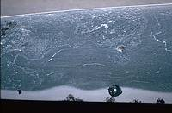
Fig. 5 fabrication texture of the sax blade from Bad Krozingen, which was made of two types of material: an outer and a core steel. (photo: Stefan Maeder)

6. For the hardening of sword blade in general and the "extraordinarily sharp edges" of the "Damaszener blade" in the particular, the following remains to be noted: in the process of the last years for the metallurgical publications on the topic of "Damaszener blade", the conditions of the archaeometallurgic research would have been regenerated to abendlaendischen swords, also the different methods could have been considered for the effective hardening from early to late medieval, as well as modern sword blades in Europe. Concrete data for the hardening of medieval Arab sword blades from the 9th century A.D. can be found in the work of Al Kindis (see ref. 37) and the paper of Schwarzlose on "the weapons of the old Arabs" from the year 1886 (see ref. 32). The most detailed scientific study about blade edges however in the reference to modern cutlery steels is written in 2002 by R. Landes.[15] which details the cut -, and/or blow abilities of straight and curved swords, where the cutting edge geometry is just as important, as is the quality and hardening of the steel.[16 ] The most concrete the Verf well-known reference to the allegedly superior sharpness of the Arab blade, used for the cut, is the famous episode with Saladins silk veil. Over its scientific value the reader himself can form his own judgement after the reading point 4 and appendix 1.

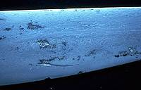
Fig. 6 clearly visible fabrication texture of a Japanese polished langsax fragment from Breisach (Foto: Stefan Mäder)

Finally, for the effectiveness of a sword blade however, neither the material nore its hardening, but the blade form and the cutting edge geometry are the deciding factors. The latters exist in the training, skill and experience of the fighters in the respective epoch and world area. A well trained fighter could at all times be effective even with a moderate blade.

On the other hand in the hands of an untrained, bending of the blade or breaking of the cutting edge can happen as f.e. was the unpleasant fate of the wielder of a Japanese sword from first-class steel with well excecuted hardening in his hands. In the writings of various cultures in Europe, the Near East, Central Asia and China and still in Japan, sword blades are described with properties bordering miracles.

[11] S. Anm. 1, Reibold, e.a. 2006, 286: „extraordinary mechanical properties“, “remarkable mechanical properties“.
[12] Das Aufzeigen der Widersprüche und Verallgemeinerungen in der Literatur zum sog. „Damaszenerstahl“ lohnt ohne Zweifel eine umfassende Aufarbeitung. Eine solche würde jedoch den Rahmen des vorliegenden Artikels sprengen.
[13] Die Literatur zu diesen Untersuchungen wurde vom Verfasser in Japan zu einer mittlerweile 10-seitigen Bibliographie zusammengefasst.
[14] Plinius, Naturalis Historia XXXIV, 41.
[15] Landes, R., 2002: Messerklingen und Stahl. Technologische Betrachtung von Messerschneiden (Bruckmühl, 2002).
[16] Eckhardt, A., pers. Mitt. u. in Vorbereitung: Das Schwert aus der Sicht des Schmiedes - Über Mythen und archaische Technologie.

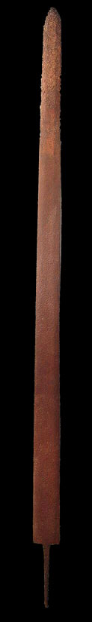
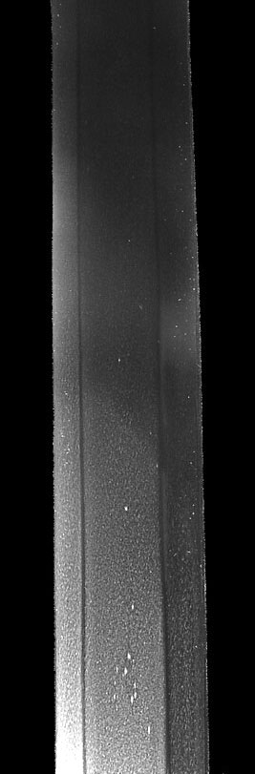
Fig. 2a (left): A late Roman riding spatha from the 3rd/4th cent. A.D. The blade is 83 cm long and 4 cm wide. At the blade tip, deep corrosion pits are visible, which refers to a separate hardening of this most strongly stressed section of the sword blade. Higher carbon-containing steel is affected more strongly by corrosion in than "softer" ferrous metals. In the front third several cuts can be seen in the blade. Blade: Provenance unknown, current location: private collection. (photo: Jens Schneider, Gundelfingen)

Abb. 2b (right): Extremely fine processing texture on the Japanese polished flat side the same blade. This is the result - in this particular case - of very frequently repeated folding and forging (refine) of the raw material. So far such photographs were only possible with Japanese sword blades. The diagonal line in the center of the photo shows how far the smith immersed the blade into the quenching medium (water) when hardening. The tang of the sword is located above, the hardened region of the blade below. Blade: Provenance unknown, current location: private collection. (photo: Jens Schneider, Gundelfingen)

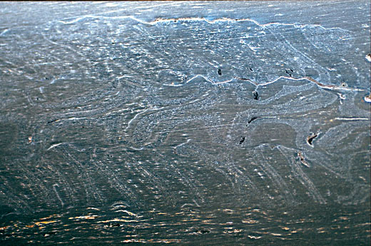

Fig. 3: Welding sample in a "worm-multicolored" Spatha blade from the 6th century A.D. from new Neudingen. The blade was polished 1999 in Japan. The sample is based on the torsion of three steel bars in opposite directions, which consist in each case of 7 alternating layers of 2 materials. It was not emphasized by corroding. Such samples, which occur at numerous conventionally conserved blades, are in the archaeological literature frequently misleadingly called "Damaszierung". At the upper and lower part, the fine layered structure of the cutting edge steel can be recognized, the way it also occurs at Japanese sword blades of later periods.

Blade: Neudingen, Kreis Schwarzwald-Baar, Gravefield in Gewann "Auf Löbern", Grave 75, o. Inv. Nr.. Current location: Centeral find depot of the Bodendenkmalpflege Baden-Württemberg, Rastatt.
(photo: Stefan Mäder)

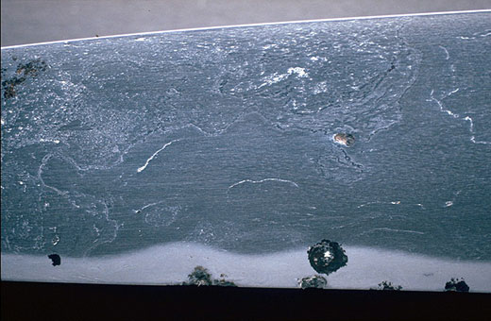
Fig. 5: Fabrication texture of the sax blade from Bad Krozingen, which was made of two material types - an outer and a core steel. For the cutting edge and local area a higher carbon-containing, hardenable steel was forged, which by numerous martensitic features in less appearing homogeneous range is to be occupied. The cutting edge was hardened separately. The detailes of the used method is not yet clear.
Blade: Bath Krozingen, Kreis Breisgau-Hochschwarzwald, grave field "Unterer Stollen ", grave 54, o. Inv. No.. Current location: Central find depot of the care of ground monuments Baden-Wuerttemberg, Rastatt. (photo: Stefan Maeder)

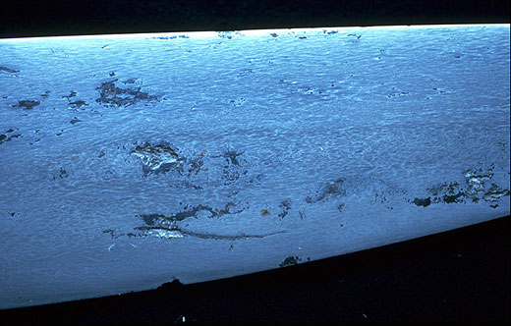
Fig. 6: Fabrication texture of a langsax fragment from Breisach. The fabrication texture is also very fine and differs clearly from the other examples. The high individuality of the fabrication textures and structural variants in connection with the research beginning of the Verf. actually offers a "low tech" option for the archaeology for the proof of workshop locations and trade routes of early to high-medieval sword blades. Through the ages in different culture areas, the highest level of the iron technology always expressed itself in the long sword blades. For their strength it was necessary to combine the contradictory characteristics of greatest possible hardness with simultaneous elasticity in a workpiece.

Blade: Breisach, Streufund, o. Inv.Nr.. Current location: private collection.
(photo: Stefan Mäder)

